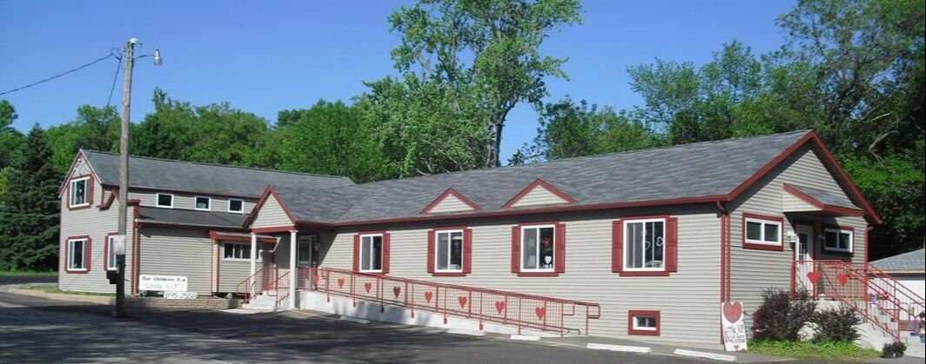
Little VIP Preschool & Child Care Center
​(262) 895-2558

Hours of Operation
Mon-Fri 6:00AM - 6:00PM
Sat - Sun Closed

Where Quality comes Naturally from the Heart!
At Little VIP we believe that every child is a special and unique individual.
A Very Important Person with individual needs and a mind just waiting to be stimulated, listened to, nurtured and loved.

"We believe childcare should be an extension of your family"

Our Mission
At "Little V.i.P." It is our intent to become known within the community as the most professional, respected, personable, high quality, comfortable child care and early education facility in the area.
Our purpose at Little VIP is to serve the surrounding communities by providing a high quality of early education and childcare, which meets and exceeds parent’s expectations.
​
Make the hours you spend away from your child valuable ones. We give loving quality care with curriculum for all ages.

V.I.P." Kids Clubhouse
BEFORE AND AFTER SCHOOL CLUB
Elementary Students
Our club is based on fostering friendships, citizenship, and wholesome family values.
Our before and after Kids Clubhouse is for children enrolled in elementary school.
Full day programming is available when school is closed.
School bus transportation to and from Lakeview School (Wind Lake), Drought School (Franksville) and
Trailside Elementary (Waterford) is provided by the school districts.
Awesome indoor and outdoor activities based on kid selected interests.
PM snack included
Homework help on request
We are open at 6AM and closed at 6PM
Kid tested and parent approved!

Daily
$11.00

Weekly (5 days)
$50.00

